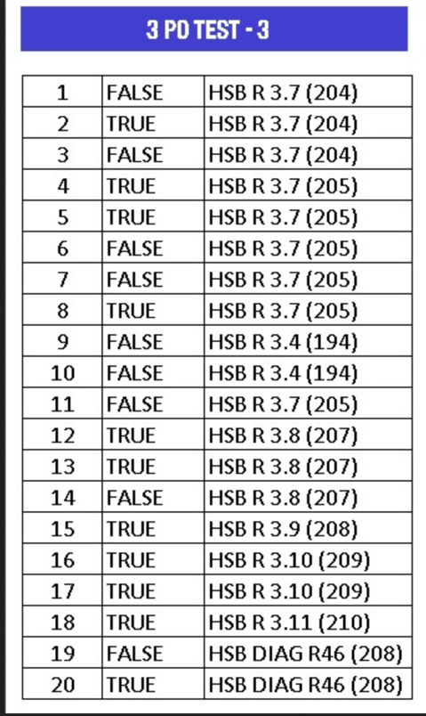
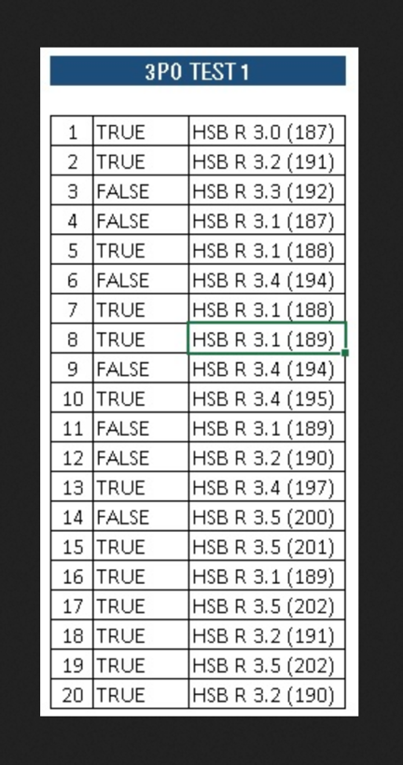
3PO TEST 1

Q1 The key to successful 3PO is one word: TRUST, you must trust your partners’.
TRUE.
Q2 At the start of all quarters except the first, Centre will always be positioned in table side.
TRUE.
Q3 The action area (also known as ‘bus station’) is the post on the strong side-refereeing.
FALSE.
Q4 Strong side-refereeing (SSR) defines the side of the court where the ball is located.
FALSE.
Q5 If the referees warm-up properly, one referee observes the court while the other 2 warm-up outside the sideline.
TRUE.
Q6 Whenever the ball reaches the low post on the strong side-refereeing, Lead referee must stay at the close down position.
FALSE.
Q7 The set-up position for Centre is at the free-throw line extended.
TRUE.
Q8 During a time-out, the referees must leave the ball on the court, at the place where the game will be resumed from.
TRUE.
Q9 The main reason why lead must not run during a rotation is that if he runs, his eyes would be bouncing while scanning the paint.
FALSE.
Q10 The ball moves to the WSR. Lead goes to close down position. He must stop there to analyse if there is a chance for a quick shot or a drive to the basket.
TRUE.
Q11 During a time-out, the three referees must stay at the centre line, opposite the scorers’ table.
FALSE.
Q12 During the jump ball, the responsibilities of Umpire 2 are to control the toss or any violation committed by the jumpers.
FALSE.
Q13 Centre referee is the last to finish a rotation.
TRUE A.
Q14 On a transition from Trail to Lead, new Lead must always go to the close down position.
FALSE.
Q15 The normal set-up position for Lead is between the lane line of the key and the three point line.
TRUE.
Q16 When 40 seconds have elapsed since the time-out started, two referees will move close to the team bench areas.
TRUE.
Q17 When the ball comes to the strong side post on Lead’s side, Lead should take a few steps wider to anticipate a possible drive.
TRUE.
Q18 After the jump ball, the crew chief will always become Trail.
TRUE.
Q19 Lead’s cross-step allows Lead to see the drive to the basket, identify the possible help defender as well as be ready for the Distance and Stationary principle.
TRUE.
Q20 During the jump ball, the responsibility of the Umpire 2 is to observe the 8 non-jumpers for possible fouls or violations.
TRUE.

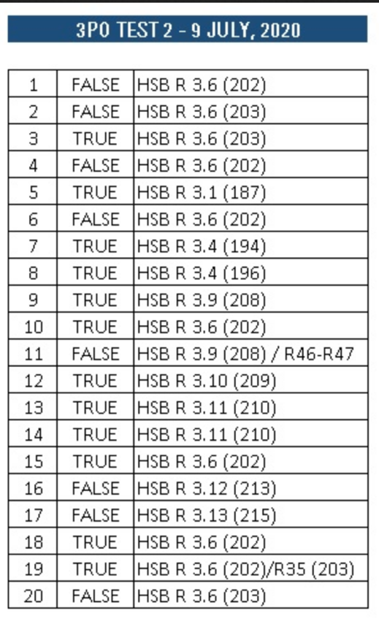

Q1 - During transition, the new Trail should always trail the play, this is, ahead of the play, in line or in front of the play.
FALSE.
Q2 - Trail working area is between centre line and free throw line extended.
FALSE.
Q3 - Trail Cross-Step can be described as “When a dribbler in Trail’s AOR moves in one direction, the Trail should move to the other direction”.
TRUE
Q4 - On transition the new Trail doesn’t need to run fast, he can be 3 or 4 metres behind the play.
FALSE.
Q5 - Trail referee is always situated in the SSR (Strong Side Refereeing).
TRUE.
Q6 - A good technique for the new Trail during transition is to use the yo-yo running, that is, getting closer and further of the play as it demands.
FALSE.
Q7 - During a proper rotation, Trail must move to Centre position as Lead is rotating to the Weak side.
TRUE.
Q8 - One of the weaknesses in the rotations is that when Trail moves to Centre, he still controls the ball instead of picking up the new weak side.
TRUE.
Q9 - Only the Trail has two primary lines to cover regarding an out-of-bounds situation and controlling backcourt violation.
TRUE.
Q10 - If the new Trail has done the transition in the right way, he should be the last to arrive in the front court and all players should be between straight arms extended (one arm side line and the other centre line) in 45º angle facing the basket.
TRUE.
Q11 - When a throw-in is on the frontcourt’s endline for the team that attacks that basket, Trail referee only has to mirror the ‘time-in’ signal to the table if the throw-in is on the opposite side.
FALSE.
Q12 - The basic principle for shot coverage is that Trail has primary coverage for all the 3 point shots in the strong side.
TRUE.
Q13 - During a rebound after a shot from the strong side, Trail has to focus on perimeter rebounds on his side: pushing, crashing and ‘over the back’.
TRUE
Q14 - During a shot from the weak side, Trail has primary coverage on goaltending or basket interference.
TRUE.
Q15 - When a valid basket is made, the new Trail must wait behind the baseline until the ball is passed to a player on the court and the player taking the throw-in has advanced onto the court also.
TRUE.
Q16 - The referee who calls and reports a foul resulting in free throws will always go opposite from the table in Trail or Centre position.
FALSE
Q17 - During a last shot, Trail referee is always responsible to control the clock and decide if the basket shall count or not..
FALSE
Q18 - One of the duties of the new Trail during transition is to control the clocks.
TRUE.
Q19 - If the new Trail is doing the transition in the proper way, he should be able to see the set-ups on the frontcourt and the next possible plays to come.
TRUE.
Q20 - When the ball moves close to Trail’s sideline, the Trail should move off the court to keep the proper angle and distance.
FALSE.

Q1 -When the ball hits the rim on an unsuccessful shot, Centre referee has to start the transition to the front court.
FALSE
Q2 - During transition Centre to Centre, the referee has to face the court.
TRUE
Q3 - When a transition play is advancing on the weak side, Centre will always continue to his set-up position and officiate the play from there.
FALSE
Q4 - Centre working area is the free throw line extended and a couple of steps up and a couple of steps down (corresponding to the limits of the free throw semicircle up and the imaginary free throw semicircle down).
TRUE
Q5 - Centre should use cross step when he finds himself straightline during any weak side drive to the basket.
TRUE
Q6 - Centre working area is usually outside the court, to avoid interfering with the players.
FALSE
Q7 - If Centre moves close to the centre line to cover a trap, Lead will always follow him and start a rotation.
FALSE
Q8 - All the plays on the weak side towards the basket are Centre’s primary.
TRUE
FALSE
Q9 When Lead scans the paint during the rotation, Centre must move to Trail position to keep the balance.
FALSE
Q10 - If we see that there are two Centres at any moment during the rotation, this means that one of them has not followed the steps for rotation.
FALSE
Q11 - In case of a double team defense on the weak side of the frontcourt, near the centre line, Centre must keep his set-up position but be ready to help Trail, who will be primary.
FALSE
Q12 - During a fast break, Centre referee still has 50% of the coverage.
TRUE
Q13 - One of the reasons for Centre to arrive quickly to the set up position during a fast break is that he has the best coverage for any possible goal tending or interference.
TRUE
Q14 - On a fast transition from Centre to Centre, speed is not so necessary, as the new Lead is primary for all the actions coming to him.
FALSE
Q15 - Regarding the lines, Centre has to cover the sideline on his side and sometimes he will have to help with the centre line on the weak side.
TRUE
Q16 - Centre referee has primary coverage on all shots on the weak side.
TRUE
Q17 - Whenever there is a shot from a dual coverage area in rectangle 2, Trail and Centre will cover their side of the play.
TRUE
Q18 - When there is a shot from the strong side, Centre has primary coverage on goal tending and basket interference.
TRUE
Q19 - When Lead is administering a throw-in on the front court’s endline, between the 3 point line and the backboard, it’s important that Centre mirrors the time-in signal to the table.
FALSE
Q20 - When Lead is administering a throw-in on the front court’s endline, between the 3 point line and the backboard, it’s important that Centre is ready to cover his side as Lead might be far from the ball if it is passed under the basket.
TRUE

