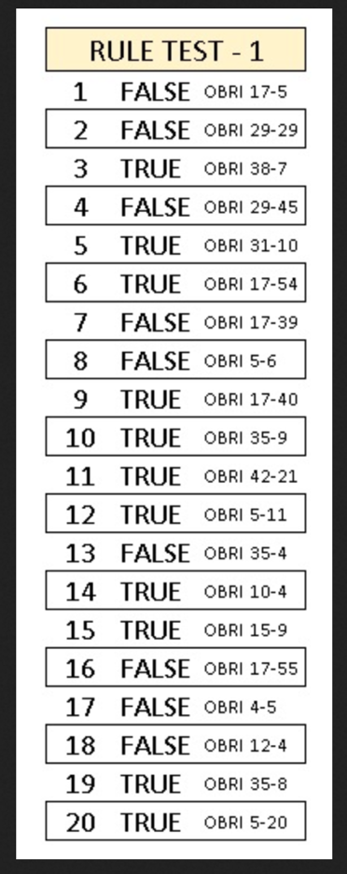
OBR 2020 RULE TEST 1
01/01/2021

Q1 - With 51 seconds on the game clock in the fourth quarter, team A is entitled to a throw-in. Before handing the ball to thrower-in A1, the referee does not show the warning ‘illegal boundary line crossing’ signal. B1 then moves his body towards A1 over the boundary line before the ball was thrown-in over the boundary line. B1 shall receive a technical foul.
TRUE
FALSE
Q2 - With 17 seconds on the shot clock, A1’s shot for a field goal is in the air when B2 in his backcourt fouls A2. This is the second team B foul in the quarter. The ball enters the basket. A1’s field goal shall count and the game shall be resumed with a team A throw-in in its frontcourt from the place nearest to where B2’s foul occurred. Team A shall have 14 seconds on the shot clock
FALSE
Q3 - A1 is charged with his fifth personal foul. This is the second team A foul in the quarter. While going to his team bench, A1 punches B2 in his face. A1 is assessed with a disqualifying foul. A1’s disqualifying foul shall be entered on the scoresheet on A1 as ‘D’ and on the team A head coach, as 'B2'. B2 shall attempt 2 free throws with no line-up. The game shall be resumed with a team B throw-in from the throw-in line in its frontcourt. Team B shall have 14 seconds on the shot clock.
TRUE
Q4 - A1 attempts a shot for a field goal with 17 seconds on the shot clock. The ball lodges between the ring and the backboard. The alternating possession arrow favours team A. The game shall be resumed with a team A throw-in in its frontcourt from the endline nearest to the backboard. Team A shall have 17 seconds on the shot clock.
FALSE
Q5 - After A1’s last free throw, the ball rebounds from the ring. During the rebound, A2 fouls B2. This is the fifth team A foul in the quarter. The ball still has the chance to enter the basket and is touched by A3. This is an interference violation by A3 and no point shall be awarded. B2 shall attempt 2 free throws.
TRUE
Q6 - A1 in his act of shooting commits a travelling violation and then scores a field goal. A1’s field goal shall not count. Team B shall be awarded a throw-in from the free-throw line extended in its backcourt. Team B shall have 24 seconds on the shot clock.
TRUE
Q7 - After B1 successful field goal in the first quarter, A1 has the ball for a throw-in from his endline. A1 passes the ball to A2 who is also behind his endline. B1 moves his hand over the boundary line and touches the ball on this pass. B1 shall receive a technical foul without warning.
FALSE
Q8 - B1 fouls A1 in his act of shooting, near the team A bench area. The ball does not enter the basket. While A1 attempts 2 or 3 free throws the team A manager passes a towel to A3, who is on the playing court. A3 shall be substituted as he is considered to have received assistance.
FALSE
Q9 - After an opponents’ successful field goal, A1 has the ball for a throw-in from his endline. A2 jumps from out-of-bounds behind his endline and while airborne catches the ball from A1’s throw-in. After that A2 passes the ball back to A1 who is still out-of-bounds behind his endline. Legal play.
TRUE
Q10 - Dribbler A1 is charged with an offensive personal foul on B1. This is the fifth team A foul in the quarter. At approximately the same time B1 is charged with an unsportsmanlike foul for hitting A1 with his elbow. The penalties shall not cancel each other. The personal foul shall always be considered as having occurred first. The throw-in penalty for team B shall be cancelled as there is a further foul penalty to be administered. A1 shall attempt 2 free throws with no line-up. The game shall be resumed with a team A throw-in from the throw-in line in its frontcourt. Team A shall have 14 seconds on the shot clock
TRUE
Q11 - Dribbler A1 commits a charging foul on B1. Before the ball is at team B’s disposal for the throw-in, B2 fouls A2. This is the third team B foul in the quarter. Both infractions occurred in the same stopped-clock period and before the ball became live for the second infraction. Therefore, the same penalties shall be cancelled. As team A was in control of the ball before the first infraction, the game shall be resumed with a team A throw-in from the place nearest to where A1’s foul occurred.
TRUE
Q12 - A1 has the ball in his hands to administer the throw-in from his frontcourt. The team A physiotherapist leaves his team bench area in the frontcourt, remains outside the playing court and fixes the taping of A1. The team A physiotherapist provided an assistance to A1 outside of his team bench area. If the assistance is completed within 15 seconds, A1 shall not be required to substitute
TRUE
Q13 - A1, with the ball still in his hands in his act of shooting, and B1 are charged with personal fouls committed on each other at approximately the same time. The ball enters the basket. The basket shall count and the game shall be resumed with a team B throw-in from the baseline.
FALSE
Q14 - A1 is in his act of shooting for a field goal when A2 fouls B2. A1 finishes his shot with a continuous motion. The ball becomes dead when A2 is charged with a team control foul. A1’s goal, if made, shall not count.
TRUE
Q15 - A1 with the ball in his hands drives to the basket for a 2-point field goal attempt. B1 fouls A1, after which A1 commits a travel violation. The ball enters the basket. A1’s field goal shall not count. A1 shall be awarded 2 free throws..
TRUE
Q16 - A1 attempts a shot for a field goal. While the ball is on its downward flight, A2 touches the ball which then enters the basket. A1’s field goal shall not count. Team B shall be awarded a throw-in from their own endline. Team B shall have 24 seconds on the shot clock.
FALSE
Q17 - A1 wears a scarf-style headband of the same solid colour as any other additional permitted equipment of his team-mates. This is allowed by the rules.
FALSE
Q18 - The crew chief tosses the ball for the opening jump ball. Immediately after the ball is legally tapped by jumper B1, the ball goes directly out-of-bounds. After the team A throw-in a held ball between A2 and B2 occurs. Team B shall be awarded an alternating possession throw-in.
FALSE
Q19 - B1 is charged with a personal foul for pushing dribbler A1. This is the fifth team B foul in the quarter. At approximately the same time A1 charged with an unsportsmanlike foul for hitting B1 with his elbow. A1 shall attempt 2 free throws with no line-up. B1 shall attempt 2 free throws with no line-up. The game shall be resumed with a team B throw-in from the throw-in line in its frontcourt. Team B shall have 14 seconds on the shot clock
TRUE
Q20 - A1 has the ball in his hands to administer the throw-in from his frontcourt. The team A physiotherapist leaves his team bench area in the backcourt, remains outside the playing court and fixes the taping of A. The team A physiotherapist provided an assistance to A1 outside of his team bench area. A1 shall be required to substitute
TRUE

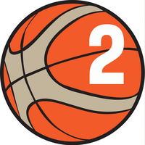
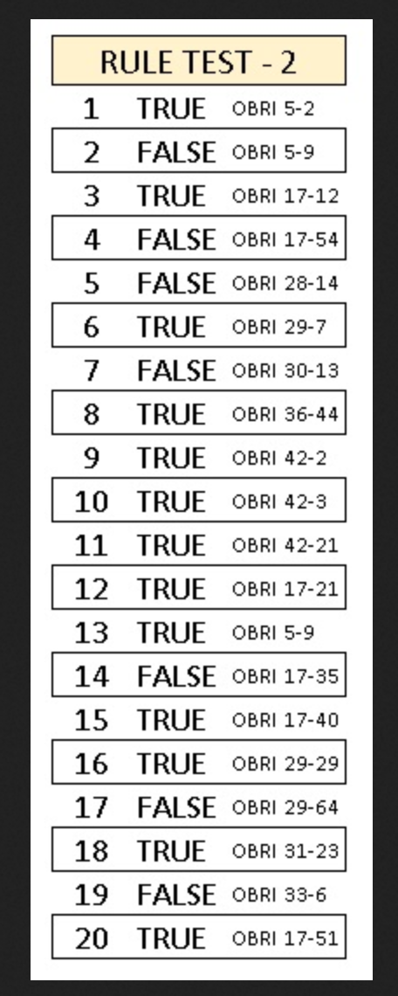
OBR 2020 RULE TEST 2
02/01/2021

Q1 - A1 appears to have an injured ankle and the game is stopped. The team A head coach enters the playing court to look after his injured player. A1 has received treatment and shall be substituted.
TRUE
Q2 – A5 scores a field goal. Thrower-in B2 indicates to the referee that the ball is wet. The referee stops the game. Substitute B9 comes on to the playing court and dries the ball. B1 has received assistance and shall be substituted.
FALSE
Q3 – After a Team A time-out during the last 2 minutes of the fourth quarter, the Team A head coach says that they want to take the throw-in from the throw-in line in their frontcourt. The game shall be resumed with a team A throw-in only when the positions of the players of both teams on the playing court show their understanding of where the game is to be resumed from.
TRUE
Q4 - A1 in his act of shooting commits a travelling violation and then scores a field goal.A1’s field goal shall not count. Team B shall be awarded a throw-in from the Place closest to where the infraction occurred. Team B shall have 24 seconds on the shot clock.
FALSE
Q5 - The 8-second period for team A expires and the violation occurs when the ball is in the air on A1’s pass from his backcourt towards his frontcourt. The team B throw-in shall be administered in its frontcourt, from the place nearest to the location of the ball when the 8-second violation occurred.
FALSE
Q6 - B1 fouls A1 in his act of shooting for a field goal. After the foul the shot clock signal sounds. The ball enters the basket. A1’s field goal shall count.
TRUE
Q7 - A1 in his backcourt passes the ball to A2 in his frontcourt. A2 touches but does not control the ball which returns to A1 still in his backcourt. This is a backcourt violation .
FALSE
Q8 - With 17 seconds on the shot clock, A1 dribbles in his backcourt when A2 is charged with a technical foul. After the free throw for Team B, the game shall be resumed with a team A throw-in from the place nearest to where the ball was located when the technical foul occurred. Team A shall have 1 second to move the ball to his frontcourt
TRUE
Q9 - B1 is charged with an unsportsmanlike foul on shooter A1. The ball is in the air when the shot clock signal sounds. The ball misses the ring. The team A shot clock violation shall be disregarded as it occurred after the unsportsmanlike foul
TRUE
Q10 - B1 fouls A1 in his act of shooting for a field goal. After the foul, with A1 still in his act of shooting, B2 fouls A1.B2’s foul shall be disregarded unless it is an Unsportsmanlike or a disqualifying foul.
TRUE
Q11 - A1, who has the ball, commits a 3 second violation. Before the ball is at team B’s disposal for the throw-in, B2 fouls A2. This is the third team B foul in the quarter. Both penalties shall cancel each other and the game shall be resumed with a Team A throw-in from the opponents’ endline, except directly behind the backboard.
TRUE
Q12 - If an infraction occurs on the playing court directly on the centre line, the throw-in shall be administered from the frontcourt at the place nearest to the centre line.
TRUE
FALSE
Q13 – A3 scores a field goal. Thrower-in B1 indicates to the referee that the ball is wet. The referee stops the game. Substitute B9 comes on to the playing court and gives a towel to B1 to dry the ball. The referee shall hand the ball to any B team player for the throw-in.
TRUE
Q14 – At the beginning of the third quarter, thrower-in A1 takes one normal lateral step to his frontcourt and passes the ball to A2 who is in his backcourt. This is a backcourt violation.
FALSE
Q15 - After an opponents’ successful field goal, A1 has the ball for a throw-in from his endline. A2 jumps from out-of-bounds behind his endline and while airborne catches the ball from A1’s throw-in. After that A2 returns to out-of-bounds behind his endline. Legal play.
TRUE
Q16 - With 17 seconds on the shot clock, A1’s shot for a field goal is in the air when B2 in his backcourt fouls A2. This is the second team B foul in the quarter. The ball misses the ring. The game shall be resumed with a team A throw-in in its frontcourt from the place nearest to where B2’s foul occurred. Team A shall have 17 seconds on the shot clock
TRUE
Q17 - With 25.2 seconds on the game clock, team A gains control of the ball. With 1 second on the shot clock, A1 attempts a shot for a field goal. While the ball is in the air, the shot clock signal sounds. The ball misses the ring and A2 catches the ball on his rebound. The referee calls the violation with the game clock showing 0.5 second. This is a shot clock violation by team A. The game shall be resumed with a team B throw-in from the place nearest to where the game was stopped, with 1.2 second on the game clock..
FALSE
Q18 - A1 attempts a shot for a 3-point field goal. The ball rebounds from the ring when B2 grasps the ring when the ball has the chance to enter the basket. The ball does not enter the basket. A1 shall be awarded 3 points. The game shall be resumed with a team B throw-in from its endline as after any successful field goal
TRUE
Q19 - A1’s shot for a field goal rebounds from the ring. A2 jumps, catches the ball and then charges into B1, who is in a legal guarding position in contact with the semi-circle area. Legal play.
FALSE
Q20 - With 1:21 on the game clock in the fourth quarter and 17 seconds on the shot clock, A2 dribbles in his backcourt when B2 taps the ball out-of-bounds. Team A is granted a time-out. Immediately after, A2 is charged with a technical foul. The team A head coach decides on a throw-in from the throw-in line in his frontcourt. After the Team B free throw, team A shall have 14 seconds on the shot clock
TRUE
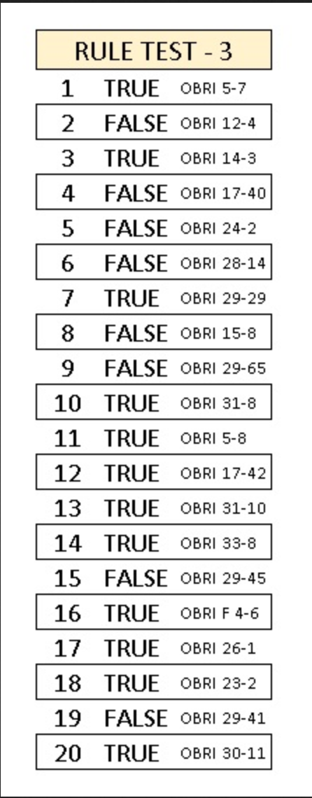
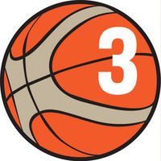
OBR 2020 RULE TEST 3
18/01/2021

Q1 - B1 fouls A1 in his act of shooting, near the team A bench area. The ball does not enter the basket. After the foul, A1 falls to the playing court and into his team’s bench area. A6 stands up and helps A1 to his feet. A1 is ready to play immediately, at the latest within approximately 15 seconds. A1 shall not be required to substitute.
TRUE
Q2 - The crew chief tosses the ball for the opening jump ball. Immediately after the ball is legally tapped by jumper B1, the ball goes directly out-of-bounds. After the team A throw-in, a double foul between A2 and B2 occurs. The crew chief shall administer another jump ball in the centre circle and any player from each team shall jump
FALSE
Q3 - Team A is in control of the ball for 15 seconds. A1 passes the ball to A2 and the ball in the air moves over the boundary line. B1 tries to catch the ball and jumps from the playing court over the boundary line. B1 still airborne taps the ball with both hands. Team A remains in control of the ball and shall have the time remaining on the shot clock .
TRUE
Q4 - After an opponents’ successful field goal, A1 has the ball for a throw-in from his endline. A2 jumps from out-of-bounds behind his endline and while airborne catches the ball from A1’s throw-in. After that A2 lands on the playing court. This is a legal play.
FALSE
Q5 - A1 has not yet dribbled and is standing still when he throws the ball against his own backboard and catches the ball again before it touches another player. This is a double dribble violation.
FALSE
Q6 - The 8-second period for team A expires and the violation occurs when team A controls the ball in its backcourt. Team B shall have 24 seconds on the shot clock.
FALSE
Q7 - With 17 seconds on the shot clock, A1’s shot for a field goal is in the air when B2 in his backcourt fouls A2. This is the second team B foul in the quarter. The ball rebounds from the ring but does not enter the basket. the game shall be resumed with a team A throw-in in its frontcourt from the place nearest to where B2’s foul occurred. Team A shall have 17 seconds on the shot clock
TRUE.
Q8 - If a player is fouled in the act of shooting for a 3 point field goal, after which he scores while he commits a travel violation, the field goal does not count and he shall always be awarded 2 free throws.
FALSE
Q9 - With 25.2 seconds on the game clock, team A gains control of the ball. With 1.2 second on the game clock and with A1 having the ball in his hand(s), the shot clock signal sounds. The referee calls the violation with the game clock showing 0.8 second. The game shall be resumed with a team B throw-in from the place nearest to where the game was stopped, with 0.8 second on the game clock..
FALSE
Q10 - After A1’s last free throw, the ball rebounds from the ring. During the rebound, B2 fouls A2. This is the third team B foul in the quarter. The ball still has the chance to enter the basket and is touched by A3. This is an interference violation. No point shall be awarded. Both throw-in penalties shall cancel each other. The game shall be resumed with an alternating possession throw-in.
TRUE
Q11 - A1 is awarded 2 free throws. While the referee reports the foul at the scorer’s table, A1 goes to a place in front of his team’s bench area at the far end of the playing court and asks for a towel. Substitute A9 passes A1 a towel. A1 dries his hands and is ready to play within approximately 15 seconds. A1 shall not be required to substitute and he shall attempt 2 free throws.
TRUE
Q12 - With 21 seconds on the shot clock in the third quarter, team A is awarded a throwin from its backcourt. Thrower-in A1 is holding the ball when B1 moves his hand(s) over the boundary line. This is a throw-in violation by B1. Team A throw-in shall be repeated. Team A shall have 24 seconds on the shot clock
TRUE
Q13 - After A1’s last free throw, the ball rebounds from the ring. During the rebound, A2 fouls B2. This is the fifth team A foul in the quarter. The ball still has the chance to enter the basket and is touched by B4. This is an interference violation. A1 shall be awarded 1 point Then B2 shall be awarded 2 free throws.
TRUE
Q14 - A1 drives to the basket in his act of shooting. While airborne, instead of completing the shot for a field goal, A1 passes the ball to A2 who is standing in the corner of the playing court. A1 then charges into B1 who is in contact with the no-charge semi-circle area.This is a legal play by A1.
TRUE
Q15 - A1 attempts a shot for a field goal with 8 seconds on the shot clock. The ball lodges between the ring and the backboard. The alternating possession arrow favours team A. Team A shall have 8 seconds on the shot clock
FALSE
Q16 - B1 is charged with an unsportsmanlike foul for hitting A1 with his elbow. The referees become uncertain if B1 hit A1 with his elbow. If the IRS review provides that no contact on A1 by B1 swinging his elbow occurred, B1’s foul shall be changed to a technical foul..
TRUE
Q17 - It is a violation when a player leaves the playing court at the endline to avoid a 3-second violation and then re-enters the restricted area.
TRUE
Q18 - Close to the sideline, A1 with the ball in his hands is closely guarded by B1 and B2. A1 touches B1 with the ball, B1 has 1 foot out-of-bounds.This is an out-of-bounds violation by B1.
TRUE
Q19 - A1 attempts a shot for a field goal. The ball touches the ring. A2 taps the ball and A3 then gains control of the ball in his backcourt. Team A shall have 24 seconds on the shot clock as soon as A3 gains control of the ball.
FALSE
Q20 - Team A is in control of the ball in its frontcourt when the ball is simultaneously touched by A1 and B1. The ball then goes into team A’s backcourt where A2 is the first to touch it. This is a backcourt violation by team A
TRUE

